(TOTAL HEALTHCARE SOLUTIONS PROVIDER)

P. O. Box GP 2821 Email: beautifulcreationsgh@yahoo.com
Accra - Ghana bcclgh@gmail.com
Tel 1: (233) 0302 667171 Website: www.bcmedicals.com
Tel 2: (233) 0302 677222
Hotline: (233) 0244316616

Your Ref: Our Ref: Date: {{date}}

SQ, NO.: {{sqNumber}}
{{hospitalName}}
{{hospitalAddress}}

Dear Sir/ Madam,
{{tenderTitle}}
Please find enclosed the following document submitted regarding our offer for the {{tenderTitle}}.

- Bid Form

- Price Schedule

- Brochure

- Company Certificates

Yours faithfully,

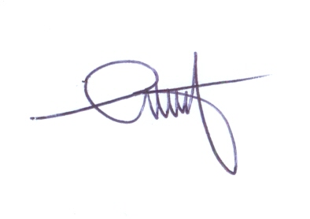
…………………
S. D. Ansong
Managing Director

